# JMeter Database Test Plan

In this section, you will learn how to create a basic test plan to test a database server.

For our test purpose we will create a database using MySQL workbench. You can use any other database server as per your convenience. You can also refer our MySQL database tutorial [**https://www.javatpoint.com/mysql-tutorial**](https://www.javatpoint.com/mysql-tutorial) to learn more about database creation.

Once you have a database server on your system. Follow these steps:

ADVERTISEMENT

ADVERTISEMENT

* Create a database with name "javatpoint".
* Create a table "tutorials".
* Insert record into tutorials.

The following image shows the database with their records which we have created using MySQL work bench.

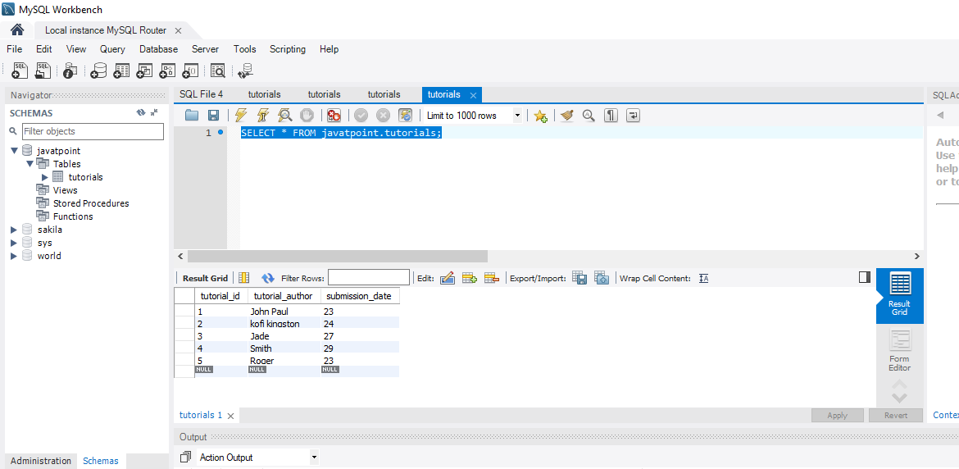

#### **Note: You need to copy the appropriate JDBC driver to "lib" directory of apache-jmeter-4.0 folder. For example, the following image shows the respective .jar files in the C:\JMeter\apache-jmeter-4.0\lib folder.**

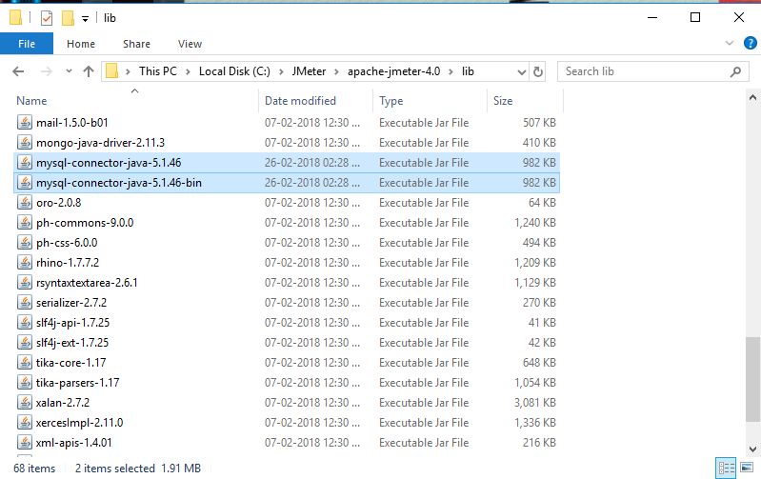

## Create JMeter Test Plan

* Go to your JMeter bin folder and double click on the ApacheJMeter.jar file to launch JMeter interface.
* Select the test plan node and right click on the selected item.
* Mouse hover on "Add" option, then elements list will be displayed.
* Select Threads (Users) > Thread Group.
* Rename this thread group as JDBC users.
* The default properties of the thread group remain unaltered.

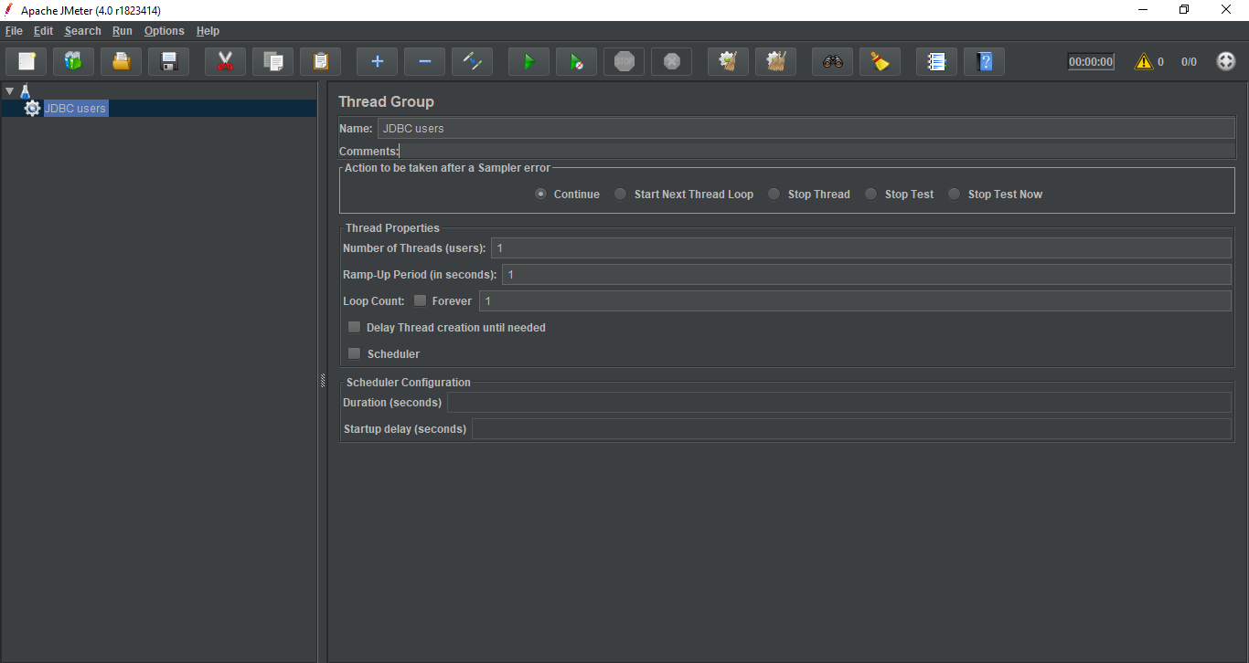

## Adding JDBC requests

* Right click on the JDBC users element.
* Mouse hover on "Add" option, then elements list will be displayed.
* Select Config Element > JDBC Connection Configuration.

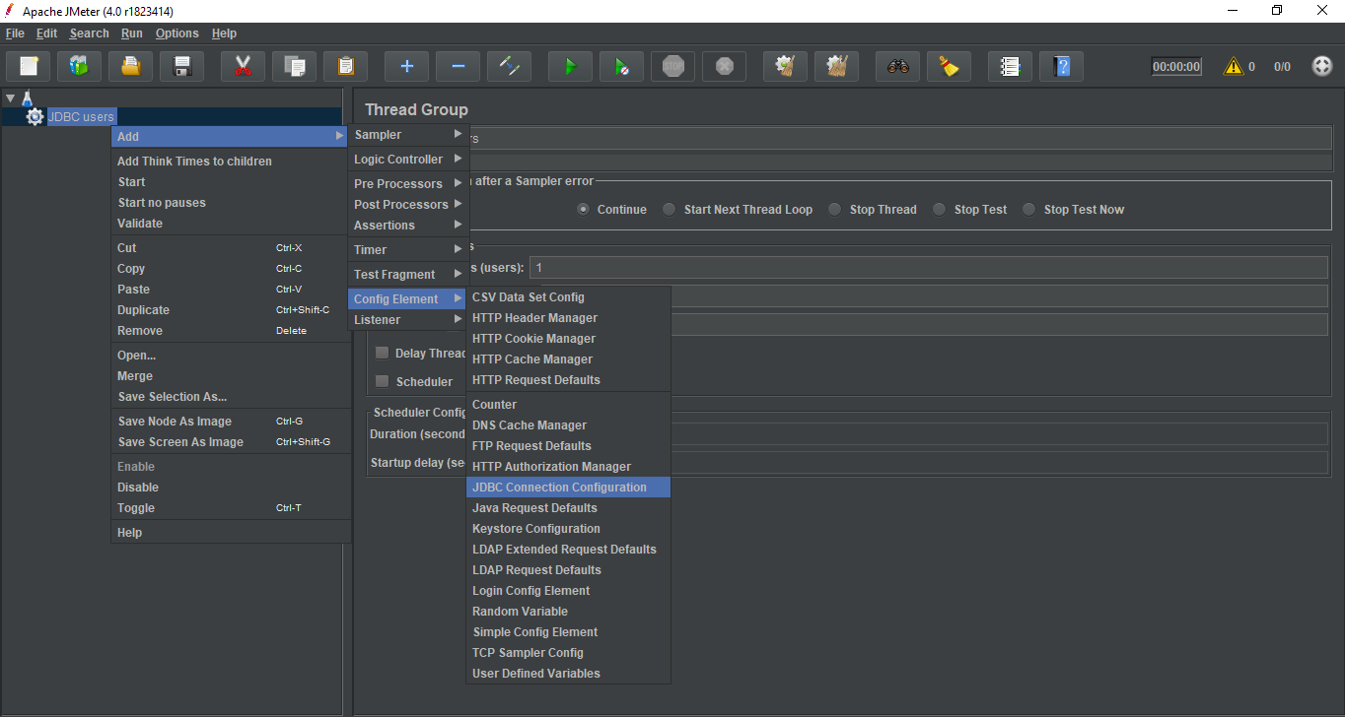

You need to set up some important fields which will determine the proper connection between your database and JMeter. These fields include -

* Variable name bound to pool - It identifies the configuration uniquely. This name will further be used by the JDBC Sampler to identify the configuration to be used. We have named it as test.
* Database URL - jdbc: mysql://localhost:3306/javatpoint
* JDBC Driver class - com.mysql.jdbc.Driver.
* User Name - root.
* Password - password for root.
* Other fields are left unaltered.

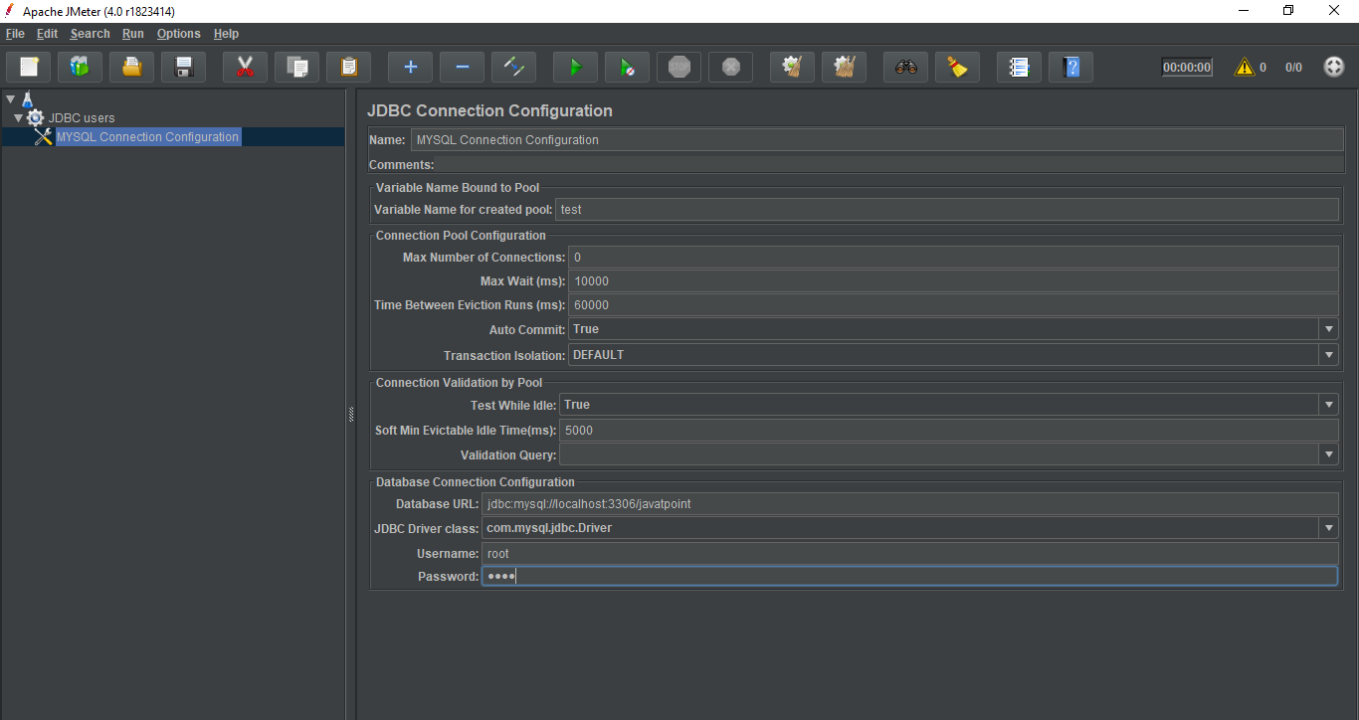

* Right click on the JDBC users element.
* Mouse hover on "Add" option, then elements list will be displayed.
* Select Sampler > JDBC request.

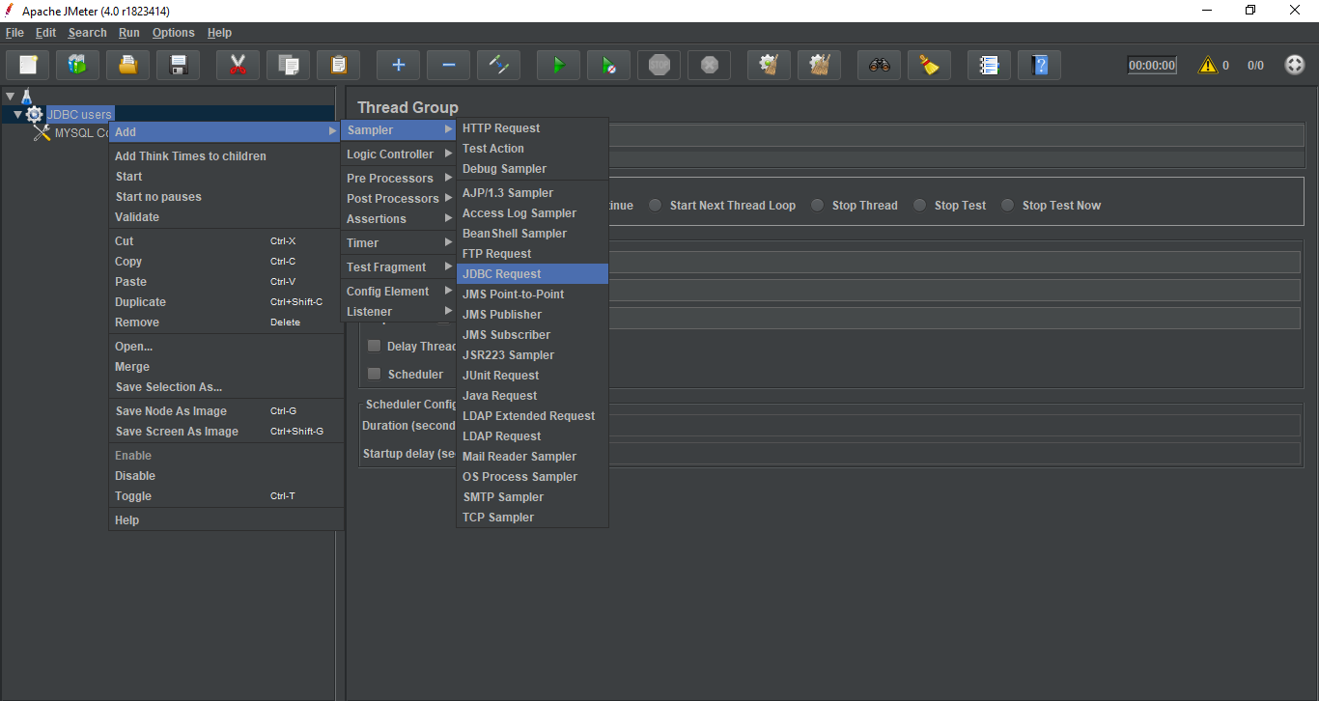

* Select this new element to view its control panel.

You need to set up some important fields. The JDBC request control panel includes -

* Name- JMeter.
* Enter the Pool Name - test (same as in the configuration element).
* Query Type - Select statement.
* Query- Enter the SQL Query string field.

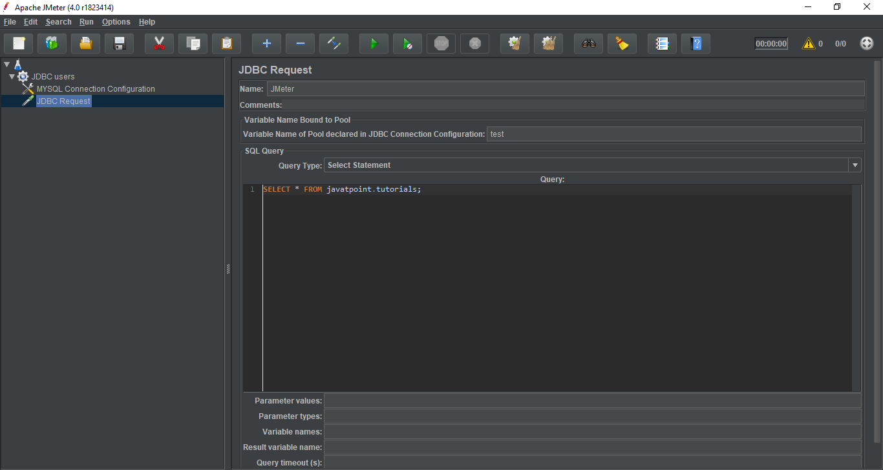

### Create Listener

* Select the JDBC users element.
* Mouse hover on "Add" option, then elements list will be displayed.
* Select Listener > View Results Tree.

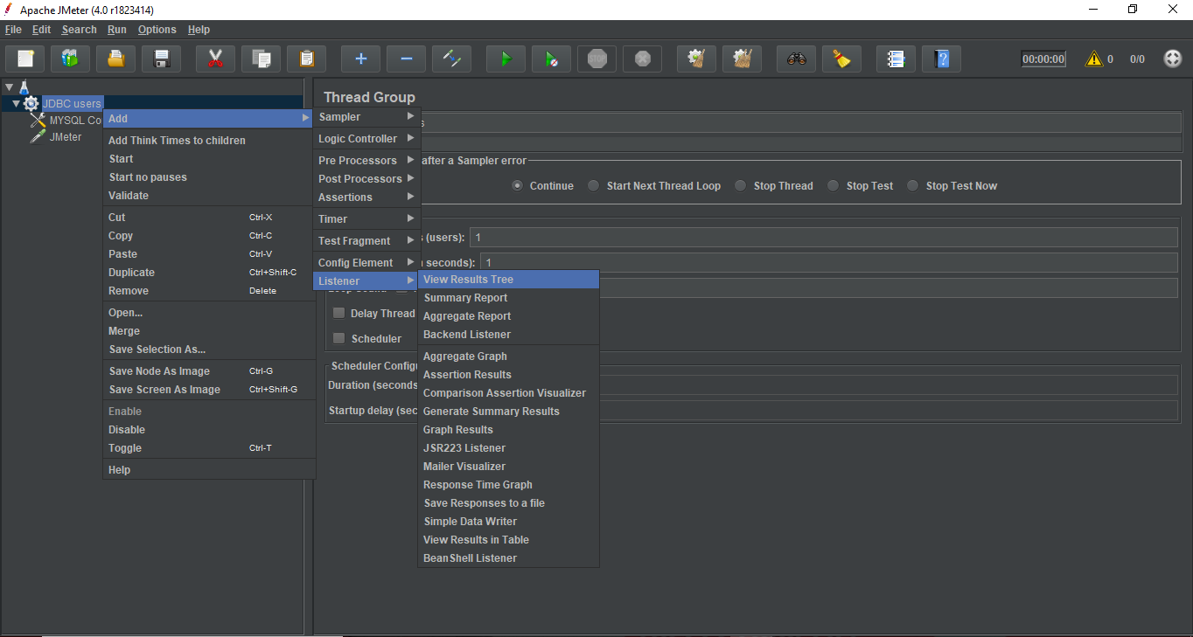

The following image shows the default View Results Tree interface.

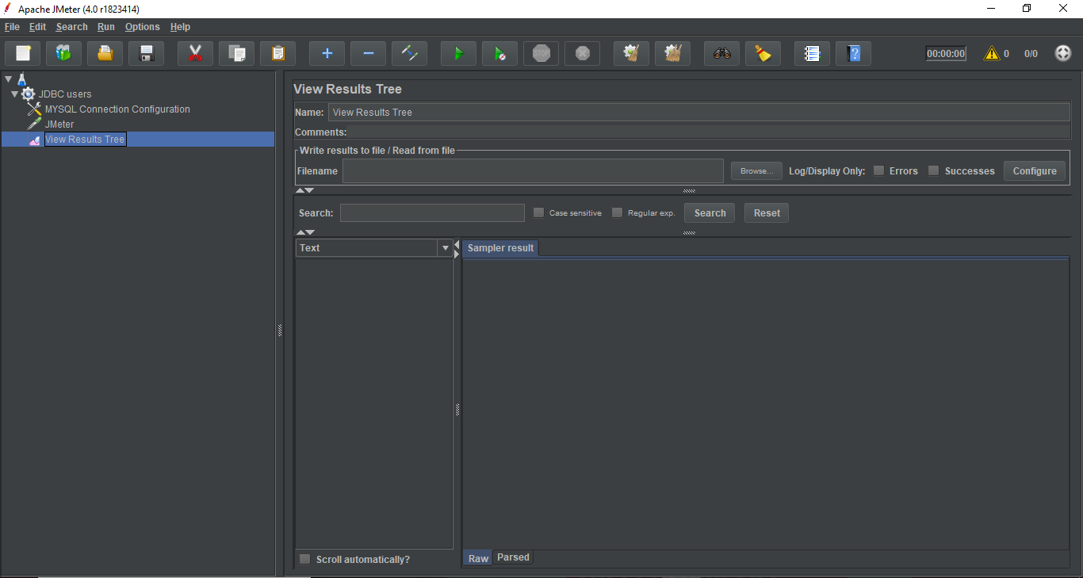

## Save and Execute Test Plan

* Click on File > Save Test Plan as.
* Save the entire test plan as DB_test.jmx.

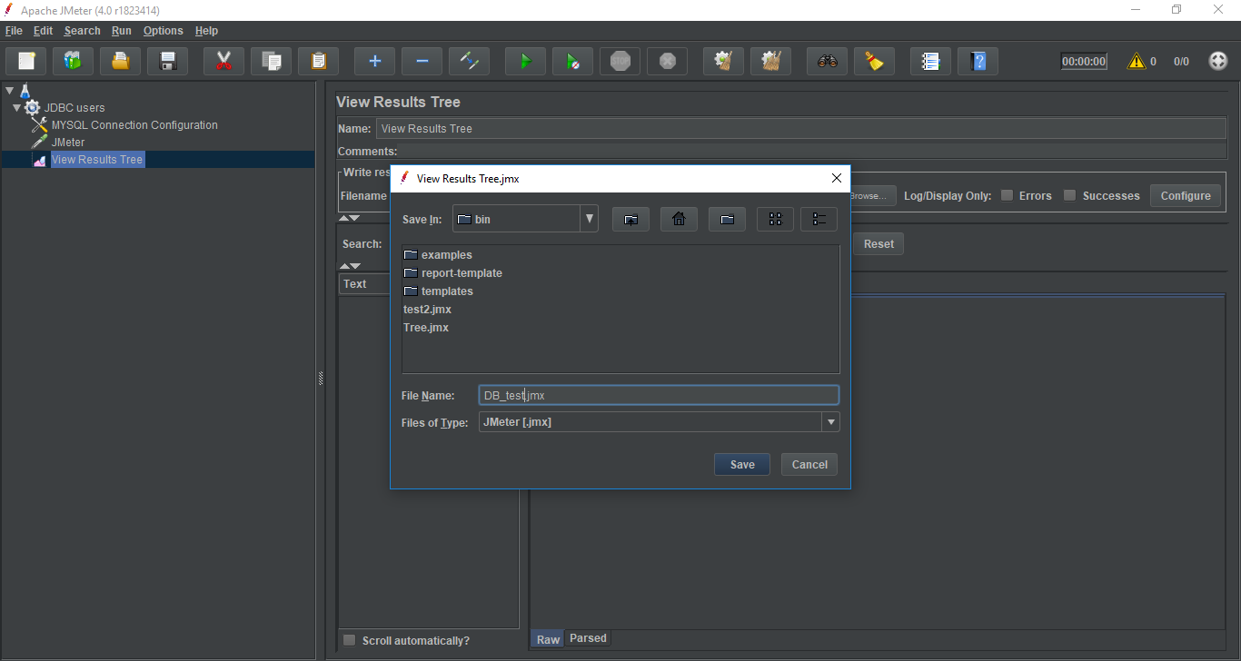

* Click on Run > Start to execute the test plan.

## Verify the Output

Green colour against the name JMeter indicates successful execution of the Test Plan.

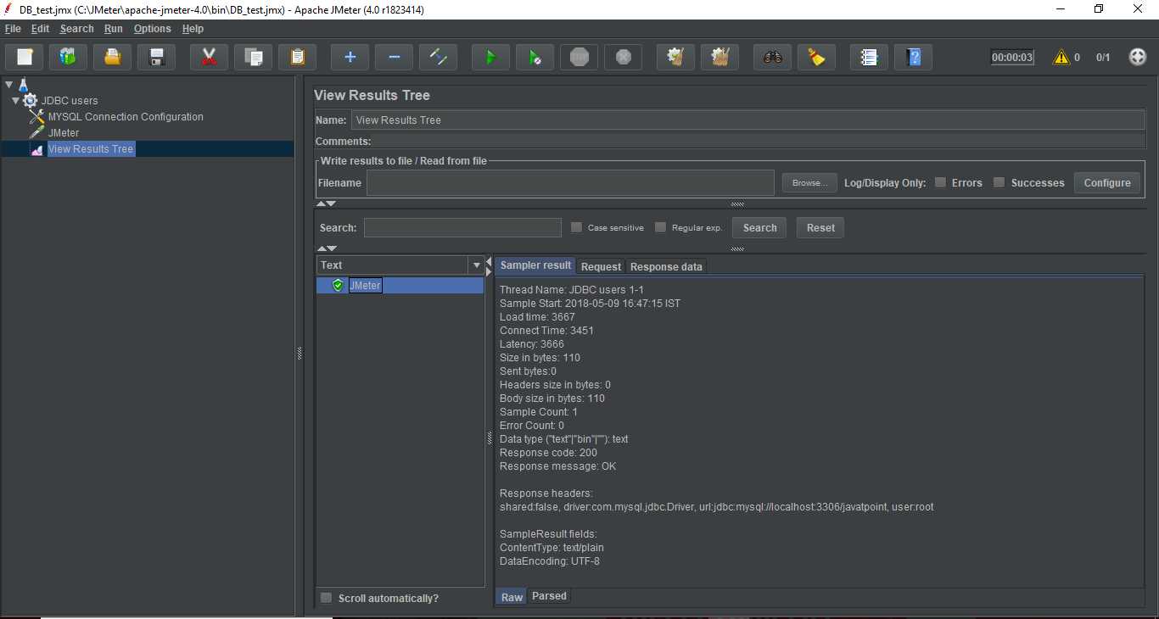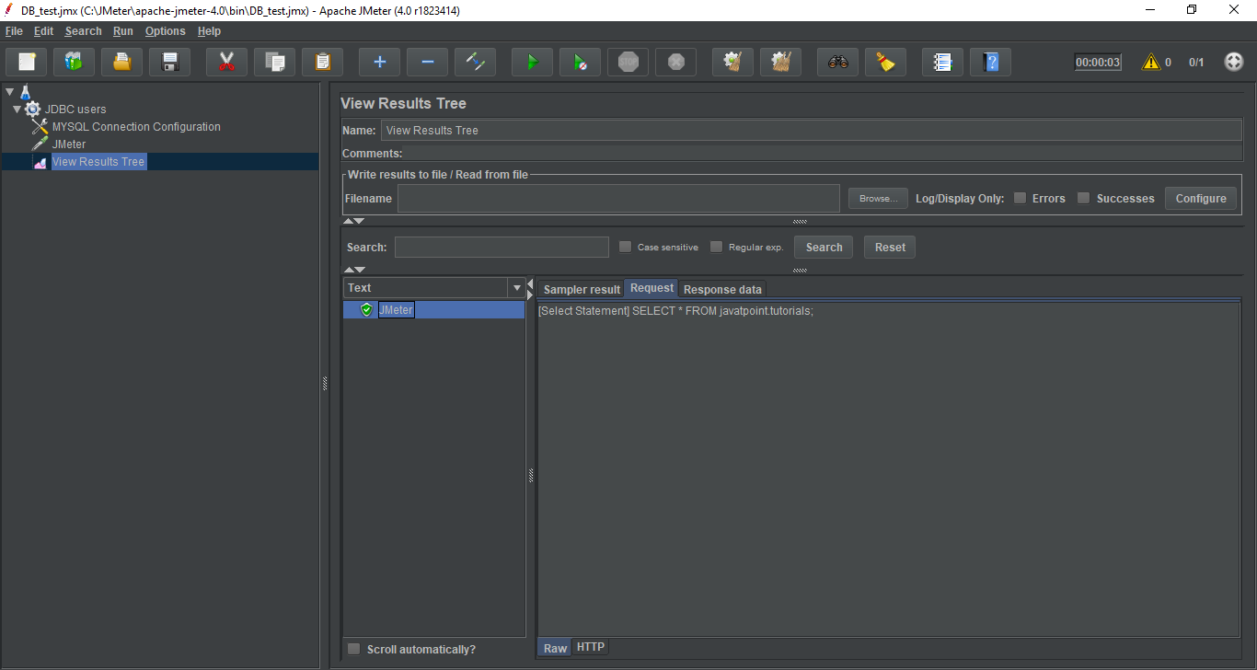

The Response data tab shows the records of database "javatpoint".

